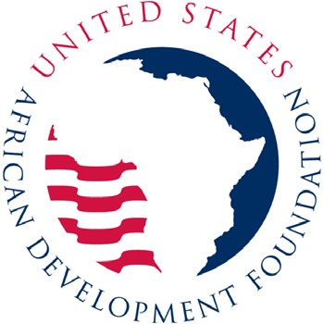

Issue Date: July 14, 2023
Closing Date: July 28, 2023

Contact Information Email: RFALiberia@usadf.gov Website: www.usadf.gov

REQUEST FOR APPLICATIONS (RFA) NUMBER: RFA-LBR-07-23

“USADF COMMUNITY DEVELOPMENT INSTITUTIONS PROGRAM: Support to
USADF Partner Organizations” in Liberia Frequently Asked Questions
- Q: Is there a specific format of the application?
A: No. The Request for Applications attached to this email provides guidance as to what elements and supporting documentation must be included in an organization’s proposal to work with USADF but does not provide a specific format for the application itself.

- Q: Is an international organization with a head office in Liberia eligible to apply?
A: Such an organization would be eligible to apply if it was legally registered in Liberia and all its principals and executive board members were Liberian citizens.

- Q: Is there a budget ceiling?
A: There is no specific budget ceiling. When preparing your budget, please keep in mind that fees or any form of profit are not allowable costs that can be funded under assistance instruments. However, all reasonable, allocable, and allowable expenses which are related to the cooperative agreement Program and are in accordance with United States Government regulations, may be paid under the cooperative agreement. Cost will not be scored, but it will be evaluated to assure reasonableness of cost elements and to assure that they conform to the requirements of the Program Description.

- Q: Does USADF have geographical target areas within Liberia?
A: USADF does not currently restrict its programming in Liberia by geography by design.

- Q: Does USADF have one Partner for the whole country, or one Partner in each region or State?
A: USADF has one Partner for the whole country.

U N I T E D S T A T E S A F R I C A N D E V E L O P M E N T F O U N D A T I O N
1400 EYE STREET NW SUITE 1000 WASHINGTON DC 20005-2248 TEL 202-233-8800 FAX 202-673-3810 WEB WWW.USADF.GOV

